Syllabus
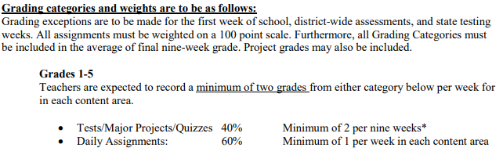
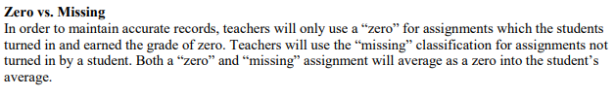
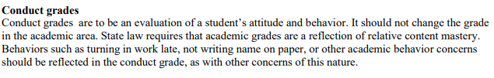
Conduct behavior will be recorded in student planners and counted up each 9 weeks. Conduct grades will be calculated off of the scale below:
